PROJECT REPORT

INTRODUCTION

The "Health Guard: Multiple Disease Prediction System" project is a crucial advancement in the field of healthcare technology, aiming to provide early detection and prediction of several critical diseases. By leveraging machine learning algorithms, specifically Support Vector Machines (SVM) and Logistic Regression, this system is designed to evaluate user inputs and predict the likelihood of conditions such as diabetes, heart disease, and Parkinson's disease. This project is envisioned to assist individuals in assessing their health risks based on their personal data, offering insights that could lead to timely medical consultations and preventive measures.

As healthcare increasingly shifts towards data-driven approaches, the need for accessible and accurate diagnostic tools grows. This project seeks to empower users by providing a reliable, user-friendly system that predicts disease risk, thus promoting proactive health management. The significance of this project lies in its potential to enhance early diagnosis and preventive care, reducing the impact of chronic diseases on individuals' lives.

OBJECTIVE
The primary objective of the "Health Guard: Multiple Disease Prediction System" is to develop an advanced machine learning tool capable of predicting the risk of three significant health conditions: diabetes, heart disease, and Parkinson's disease. This project aims to utilize sophisticated machine learning algorithms, specifically Support Vector Machines (SVM) and Logistic Regression, to analyse user-provided health data and deliver accurate predictions regarding the likelihood of these diseases. By harnessing the power of these algorithms, the system intends to offer users a preliminary assessment of their disease risk based on their individual health information.
A key goal of the project is to enhance early detection of potential health issues. By providing users with a risk assessment, the system enables timely intervention and preventive measures, which can be crucial in managing and mitigating the effects of these conditions. This proactive approach to health management is designed to facilitate better health outcomes and reduce reliance on traditional diagnostic methods.
Moreover, the "Health Guard" system is committed to promoting user empowerment. It provides a platform where individuals can input their health data and receive actionable insights, allowing them to make informed decisions about their health. This user-centric approach not only supports better health management but also fosters a greater awareness of personal health risks. Ultimately, the project aims to improve overall health management by offering a reliable and accessible tool for predicting disease risks, thereby contributing to a more informed and health-conscious society.

PROPOSED SYSTEM

The "Health Guard: Multiple Disease Prediction System" employs advanced machine learning algorithms, namely Support Vector Machines (SVM) and Logistic Regression, to predict the risk of three major health conditions: diabetes, heart disease, and Parkinson’s disease. Here is an overview of how each algorithm operates within the system:

Support Vector Machines (SVM)

Support Vector Machines (SVM) is a supervised machine learning algorithm that excels at classification tasks. SVM aims to find the optimal hyperplane that separates different classes in the feature space with the maximum margin. The fundamental concept is to maximize the margin between data points of different classes to achieve the best possible separation.

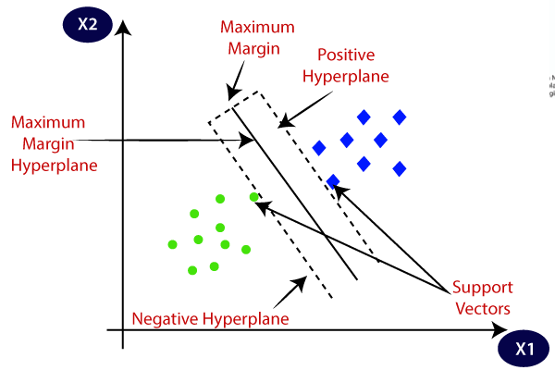

Figure 2.1 Linear SVM

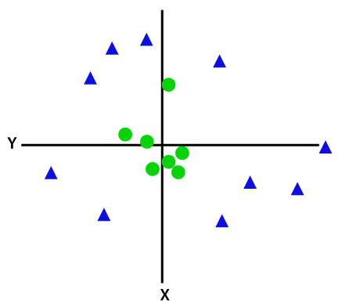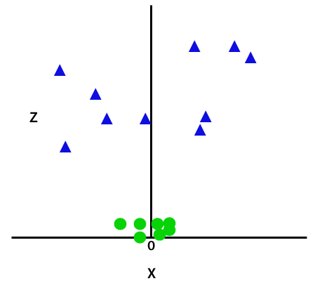

Figure 2.2 Non - Linear SVM

Logistic Regression

Logistic Regression is another supervised learning algorithm used for binary classification. It predicts the probability of a categorical dependent variable based on one or more independent variables. The model estimates probabilities using the logistic function, making it particularly suitable for predicting health risks.

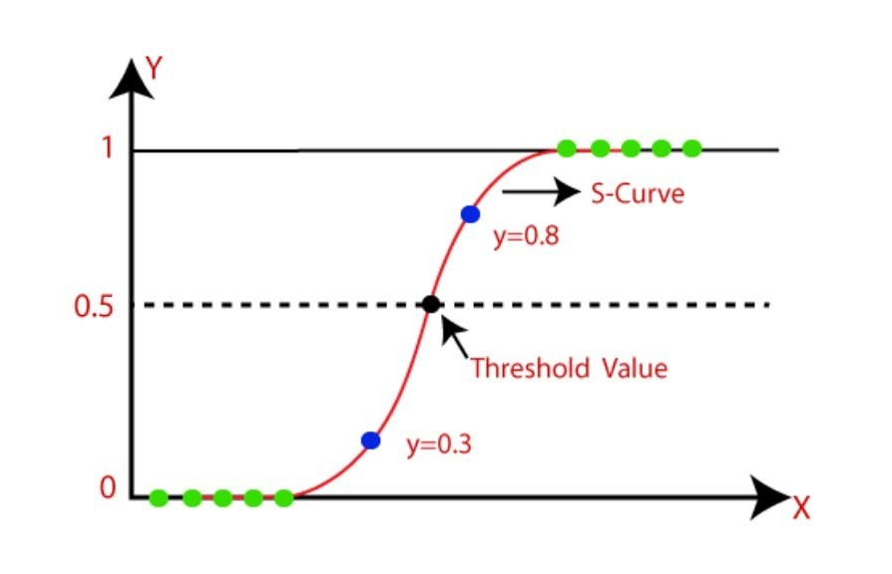

PROPOSED SYSTEM PHASES

Phase 1: Data Collection
In this initial phase, we gather health-related data from reliable sources such as medical records, health surveys, and publicly available health datasets. The collected data will include a variety of features relevant to disease prediction, such as age, gender, blood pressure, cholesterol levels, BMI, and medical history. Ensuring data quality and comprehensiveness is crucial, as the accuracy of the predictions depends on the richness and reliability of the data.
Phase 2: Data Preprocessing
Once the data is collected, it undergoes preprocessing to prepare it for analysis. This phase includes:
- Data Cleaning: Handle missing values by imputation or removal, and address any inconsistencies or errors in the data.
- Data Transformation: Normalize or standardize the data to bring all features to a comparable scale, which helps improve the performance of machine learning algorithms.
- Feature Selection: Identify and select the most relevant features for disease prediction to reduce dimensionality and improve model efficiency.

Phase 3: Model Training
In this phase, we train the machine learning models using the prepared dataset. The key steps include:
- Splitting the Data: Divide the dataset into training and testing subsets to evaluate model performance effectively. A common split ratio is 80% for training and 20% for testing.
- Training Algorithms: Apply Support Vector Machines (SVM) and Logistic Regression to the training data. The SVM model will find the optimal hyperplane for classification, while the Logistic Regression model will estimate the probability of disease presence.
- Model Evaluation: Assess the performance of the trained models using metrics such as accuracy, precision, recall, and F1-score on the testing subset. This evaluation ensures that the models generalize well to new data.

Phase 4: Model Testing and Validation
After training, the models are tested with unseen data to validate their predictive capabilities. This phase involves:
- Testing Predictions: Use the trained models to predict disease risk based on new user input data.
- Performance Validation: Compare the model predictions against actual outcomes to measure their accuracy and reliability.

Phase 5: Integration with User Interface
The final phase involves integrating the predictive models into a user-friendly interface. This includes:
- Developing the Interface: Create a web or mobile application where users can input their health data and receive predictions about their risk of diabetes, heart disease, and Parkinson’s disease.
- Model Deployment: Implement the trained models within the application, ensuring that the prediction process is seamless and efficient.
- User Testing: Conduct user testing to ensure that the interface is intuitive and that the predictions are accurately displayed.

Phase 6: Continuous Improvement
In the ongoing development phase, the system undergoes continuous enhancement, including:
- Model Updates: Regularly update the models with new data to improve accuracy and adapt to emerging trends.
- Feature Expansion: Incorporate additional health parameters and features to provide a more comprehensive risk assessment.
- User Feedback: Collect and analyze user feedback to refine the interface and enhance the overall user experience.

- BLOCK DIAGRAM

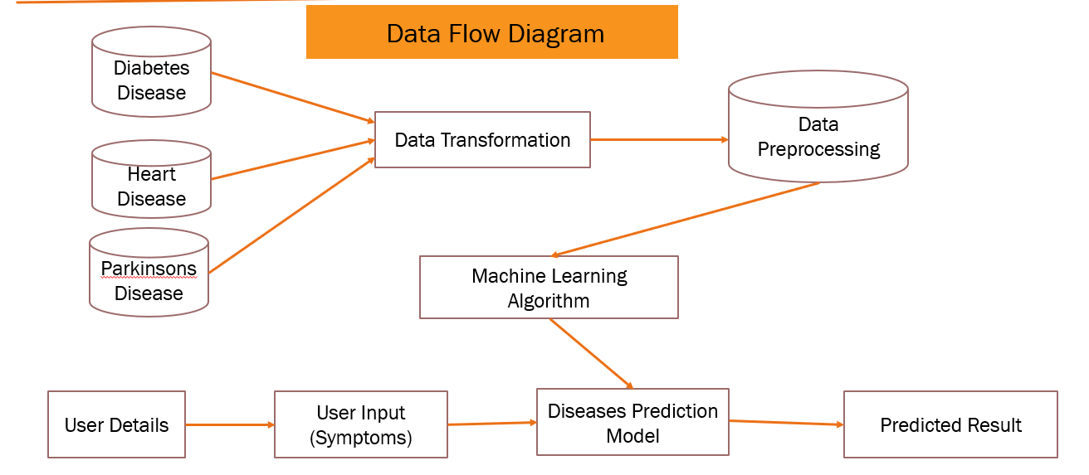
Figure 3.1
FACTORS THAT AFFECT DISEASE PREDICTION:

1. Health Data Quality
The accuracy of predictions in the "Health Guard" system heavily depends on the quality of the health data provided. High-quality, comprehensive data with accurate and up-to-date health records ensures that the machine learning models—SVM and Logistic Regression—can make reliable predictions. Incomplete or inaccurate data, such as missing values or incorrect medical information, can lead to erroneous predictions and reduce the effectiveness of the system.
2. Data Diversity and Representativeness
The diversity and representativeness of the health data play a crucial role in the performance of the disease prediction models. A dataset that includes a wide range of demographic groups, medical conditions, and lifestyle factors allows the models to learn from a broader spectrum of cases. This diversity helps in creating more generalized models that can accurately predict disease risk across different populations. Conversely, a lack of diversity in the dataset can lead to biased predictions and limit the applicability of the system.
3. Feature Selection and Relevance
The selection and relevance of features (input variables) used in the predictive models are essential. For the "Health Guard" system, features such as age, blood pressure, cholesterol levels, and family medical history are crucial for accurate predictions of diabetes, heart disease, and Parkinson’s disease. Irrelevant or less informative features can introduce noise into the models, while important features that are omitted can reduce the predictive accuracy. Effective feature engineering and selection processes ensure that the most relevant health indicators are used for prediction.
4. Model Training and Tuning
The performance of the SVM and Logistic Regression models is influenced by how well they are trained and tuned. Proper training involves using a sufficient amount of data to allow the models to learn the underlying patterns associated with disease risk. Model tuning, including adjusting hyperparameters and choosing appropriate kernel functions for SVM, can significantly impact the accuracy of predictions. Insufficient training or poorly tuned models may result in lower accuracy and unreliable risk assessments.
5. User Input Accuracy
The accuracy of predictions also depends on the precision of the user inputs. When users provide health data such as symptoms, lifestyle choices, and medical history, any inaccuracies or incomplete information can affect the prediction results. Ensuring that users provide accurate and comprehensive information is vital for the system to deliver reliable predictions.
6. Evolving Medical Knowledge
The field of medical research is continually evolving, with new findings and insights emerging regularly. The "Health Guard" system must adapt to these advancements by incorporating new medical knowledge and updating the predictive models accordingly. Failure to keep the models updated with the latest research can lead to outdated predictions and reduced effectiveness.
7. Data Privacy and Security
Protecting user data privacy and ensuring data security are critical factors. The system must adhere to strict data protection regulations and implement robust security measures to safeguard sensitive health information. Breaches in data security or mishandling of personal information can undermine user trust and the overall integrity of the system.
8. Technological Infrastructure
The performance and scalability of the "Health Guard" system depend on the technological infrastructure supporting it. Efficient data processing, storage capabilities, and computational resources are necessary to handle large volumes of health data and perform complex calculations for predictions. Inadequate infrastructure can lead to slower processing times and reduced system performance.

BRIEF OUTLINE OF ALGORITHM
To begin, import the necessary Python libraries required for the "Health Guard: Multiple Disease Prediction System." Essential libraries include NumPy and Pandas for data manipulation, Scikit-learn for implementing machine learning algorithms such as Support Vector Machines (SVM) and Logistic Regression, and Matplotlib and Seaborn for data visualization.
Start by collecting and loading health-related datasets that contain features relevant to predicting diabetes, heart disease, and Parkinson's disease. Load this data into a Pandas DataFrame and use functions like head(), info(), and describe() to inspect and understand the dataset’s structure.
Next, preprocess the data by addressing any missing values, correcting errors, and removing duplicates. Normalize or standardize the features to ensure they are on a comparable scale, which helps in improving model performance. Encode categorical variables as needed to prepare the data for modeling.
Proceed to select relevant features that are significant for predicting the diseases. Use techniques such as correlation analysis or statistical tests to ensure that only the most informative features are included.
Then, split the data into training and testing subsets, typically using an 80/20 ratio. This allows the models to be trained on one portion of the data and evaluated on another, ensuring that the models are tested on unseen data.
Train the models using the training dataset. For Support Vector Machines (SVM), choose appropriate kernel functions and tune hyperparameters to optimize performance. For Logistic Regression, adjust regularization parameters to prevent overfitting and improve accuracy.
Evaluate the performance of the models using the testing dataset, measuring metrics such as accuracy, precision, recall, and F1-score to assess how well each model predicts the diseases. Compare these metrics to determine the most effective model.
Use the trained models to make predictions on new user input data. The models will output the likelihood of the user having diabetes, heart disease, or Parkinson’s disease. Ensure that these predictions are communicated clearly to the user.
Visualize the results using Matplotlib and Seaborn to illustrate prediction distributions, feature importance, and model performance. This helps in interpreting the results and gaining insights into the predictions.
Finally, integrate the trained models into a user-friendly application or web interface, allowing users to input their health data and receive disease risk predictions. Make sure the interface is intuitive and provides actionable insights based on the predictions. Regularly update the models with new data and research findings to maintain accuracy and relevance, incorporating user feedback to continuously improve the system.

SOFTWARE REQUIREMENT FOR DEVELOPMENT
Python: The primary programming language for implementing machine learning algorithms and developing the project.
Machine Learning Libraries: Scikit-learn for comprehensive machine learning tasks, NumPy and Pandas for numerical operations and structured data management.
Web Framework: Django for creating a lightweight web interface to integrate the machine learning model.
Data Visualization: Matplotlib and Seaborn for creating visualizations representing data trends and insights.
Data Processing: Scipy, an open-source library for mathematics, science, and engineering, useful for scientific computing tasks, including data processing.
IDE (Integrated Development Environment): Jupyter Notebook or PyCharm for interactive development and experimentation with Python code.
Database (Optional): SQLite or MongoDB depending on project requirements for storing and managing real estate data.
Virtual Environment: Virtualenv for creating an isolated Python environment to prevent dependency conflicts.
HTML/CSS/JavaScript (Optional): Basic knowledge of web development using HTML, CSS, and JavaScript may be beneficial for creating a more sophisticated user interface.

SOURCE CODE

DIABETES PREDICTION
import numpy as np
import pandas as pd
from sklearn.model_selection import train_test_split
from sklearn import svm
from sklearn.metrics import accuracy_score
#Loading of the dataset
diabetes_dataset=pd.read_csv('diabetes.csv')
diabetes_dataset.head()
diabetes_dataset.shape
diabetes_dataset.describe()
diabetes_dataset['Outcome'].value_counts()
diabetes_dataset.groupby('Outcome').mean()
# separation of the dataset
x=diabetes_dataset.drop(columns='Outcome',axis=1)
y=diabetes_dataset['Outcome']
print(x)
print(y)
# splitting of dataset in training and testing
x_train,x_test,y_train,y_test=train_test_split(x,y,test_size=0.2,stratify=y,random_state=2)
x_train.shape
print(x_train.shape,y_train.shape,x_test.shape,y_test.shape)
# training of the model
classifier=svm.SVC(kernel='linear')
classifier.fit(x_train,y_train)
# accuracy score on the training data
x_train_prediction=classifier.predict(x_train)
training_data_accuracy=accuracy_score(x_train_prediction,y_train)
training_data_accuracy
#accuracy score on the testing data
x_test_prediction=classifier.predict(x_test)
test_data_accuracy=accuracy_score(x_test_prediction,y_test)
test_data_accuracy
#saving the trained model
import pickle
filename='diabetes_model.sav'
pickle.dump(classifier,open(filename,'wb'))
loaded_model=pickle.load(open('diabetes_model.sav','rb'))
input_data=(5,166,72,19,175,25.8,0.58,51)
input_data_as_numpy_array=np.asarray(input_data)
input_data_reshaped=input_data_as_numpy_array.reshape(1,-1)
prediction=loaded_model.predict(input_data_reshaped)
print(prediction)
if(prediction[0]==0):
print('The person is not diabetic')
else:
print('The person is diabetic')

FUTURE SCOPE OF PROJECT
The "Health Guard: Multiple Disease Prediction System" has substantial potential for future growth and refinement. One key area for development is the enhancement of predictive models used for diagnosing health conditions. By incorporating advanced machine learning techniques, such as ensemble methods or deep learning models, the system can achieve higher accuracy and more reliable predictions. This involves exploring and implementing new algorithms that can better capture the complex relationships between health indicators and disease risk.
Another avenue for improvement is expanding the feature set used in the prediction models. Integrating additional health parameters, such as genetic information, detailed lifestyle factors, and environmental influences, could provide a more nuanced understanding of disease risks. This broader approach may lead to more precise predictions and personalized health assessments.
Geographical expansion represents another significant opportunity. Adapting the system to accommodate diverse healthcare data from different regions or countries would enhance its applicability and usefulness on a global scale. This would require incorporating region-specific health data and adapting the models to account for variations in health trends and medical practices.
Moreover, the integration of real-time data and wearable health technology could further refine predictions and provide ongoing health monitoring. As advancements in technology continue and more comprehensive datasets become available, the system can evolve to offer more accurate, timely, and actionable health insights, ultimately supporting better preventive care and early intervention strategies.

REFERENCES
[1] Poudel RP, Lamichhane S, Kumar A, et al.Predicting the risk of type 2 diabetes mellitus using data mining techniques. J Diabetes Res.2018;2018:1686023.
[2] Deo RC. Machine learning in medicine. Circulation. 2015;132(20):1920-1930.
[3] Breiman L, Friedman JH, Olshen RA, Stone CJ.Classification and Regression Trees. Wadsworth and Brooks; 1984.
[4] Parashar A, Gupta A, Gupta A. Machine learning techniques for diabetes prediction. Int J Emerg Technol Adv Eng. 2014;4(3):672-675.
[5] Breiman L, Friedman JH, Olshen RA, Stone CJ. Classification and Regression Trees. Wadsworth and Brooks; 1984.

